WE-LAB-4
22K-5195

1)
- function dataTypes() {
- const str = "K225195";
- const person = { name: "Laiba", age: 21 };
- let numbers = [1, 2, 3, 4];
- let number = 10;
- var isActive = true;
- let undefinedVar;
- const emptyValue = null;
- const uniqueSymbol = Symbol("id");
- let bigNumber = 1234567890123456789012345678901234567890n;

- console.log("Object:", person);
- console.log("String:", str);
- console.log("Array:", numbers);
- console.log("Number:", number);
- console.log("Boolean:", isActive);
- console.log("Undefined:", undefinedVar);
- console.log("Null:", emptyValue);
- console.log("Symbol:", uniqueSymbol);
- console.log("BigInt:", bigNumber);
- }

- dataTypes();
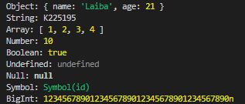

2)
function reverseString(str) {
let reversedStr = str.split('').sort().reverse().join('');
console.log("Reversed String :", reversedStr);
}
reverseString("Laiba");
3)
function printTable(number) {
let result = '';
for (let i = 1; i <= 10; i++) {
result += `${number} * ${i} = ${number * i}\n`;
}
console.log(result);
}

printTable(7);

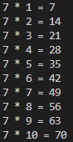

4)
const readline = require('readline');
const rl = readline.createInterface({
input: process.stdin,
output: process.stdout
});
rl.question('enter first num: ', (num1) => {
rl.question('enter second numb: ', (num2) => {
num1 = parseFloat(num1);
num2 = parseFloat(num2);

const add = num1 + num2;
const subtract = num1 - num2;
const multiply = num1 * num2;
const divide = num1 / num2;

console.log(`Addition: ${add}`);
console.log(`Subtraction: ${subtract}`);
console.log(`Multiplication: ${multiply}`);
console.log(`Division: ${divide}`);
rl.close();
});
});

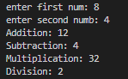

5)
function isPalindrome(str) {
const reversed = str.split('').reverse().join('');
if (str === reversed) {
console.log("string is a palindrome.");
} else {
console.log("string is not a palindrome.");
}
}
isPalindrome("civic");
isPalindrome("laiba");

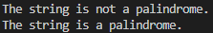

6)
<!DOCTYPE html>
<html lang="en">
<head>
<meta charset="UTF-8">
<meta name="viewport" content="width=device-width, initial-scale=1.0">
<title>Sign-Up Form</title>
</head>
<body>
<h1>Sign-Up Form</h1>
<form id="signupForm">
<label for="username">Username:</label>
<input type="text" id="username" required><br><br>

<label for="email">Email:</label>
<input type="email" id="email" required><br><br>

<label for="password">Password:</label>
<input type="password" id="password" required><br><br>

<button type="submit">Submit</button>
</form>

<h2>Entered Information:</h2>
<p id="displayUsername"></p>
<p id="displayEmail"></p>
<p id="displayPassword"></p>

<script>
const form = document.getElementById('signupForm');
const displayUsername = document.getElementById('displayUsername');
const displayEmail = document.getElementById('displayEmail');
const displayPassword = document.getElementById('displayPassword');

form.addEventListener('submit', function(event) {
event.preventDefault();

const username = document.getElementById('username').value;
const email = document.getElementById('email').value;
const password = document.getElementById('password').value;

displayUsername.textContent = "Username: " + username;
displayEmail.textContent = "Email: " + email;
displayPassword.textContent = "Password: " + password;
});
</script>
</body>
</html>



7)
<!DOCTYPE html>
<html lang="en">
<head>
<meta charset="UTF-8">
<meta name="viewport" content="width=device-width, initial-scale=1.0">
<title>Sign-Up Form with Validation</title>
</head>
<body>
<h1>Sign-Up Form with Validation</h1>
<form id="signupForm">
<label for="username">Username (min 5 characters):</label>
<input type="text" id="username" required><br><br>

<label for="contact">Contact Number:</label>
<input type="text" id="contact" required><br><br>

<label for="email">Email:</label>
<input type="email" id="email" required><br><br>

<label for="password">Password (min 8 characters):</label>
<input type="password" id="password" required><br><br>

<label for="gender">Gender:</label>
<input type="radio" id="male" name="gender" value="Male"> Male
<input type="radio" id="female" name="gender" value="Female"> Female<br><br>

<label for="terms">Agree to Terms:</label>
<input type="checkbox" id="terms" required> I agree to the terms<br><br>

<button type="submit">Submit</button>
</form>

<h2>Entered Information:</h2>
<p id="displayUsername"></p>
<p id="displayContact"></p>
<p id="displayEmail"></p>
<p id="displayPassword"></p>
<p id="displayGender"></p>
<p id="displayTerms"></p>

<script>
const form = document.getElementById('signupForm');
const displayUsername = document.getElementById('displayUsername');
const displayContact = document.getElementById('displayContact');
const displayEmail = document.getElementById('displayEmail');
const displayPassword = document.getElementById('displayPassword');
const displayGender = document.getElementById('displayGender');
const displayTerms = document.getElementById('displayTerms');

form.addEventListener('submit', function(event) {
event.preventDefault();

const username = document.getElementById('username').value;
const contact = document.getElementById('contact').value;
const email = document.getElementById('email').value;
const password = document.getElementById('password').value;
const gender = document.querySelector('input[name="gender"]:checked');
const terms = document.getElementById('terms').checked;

const usernameRegex = /^[a-zA-Z0-9]{5,}$/;
const contactRegex = /^[0-9]{10}$/;
const passwordRegex = /^(?=.*[A-Za-z])(?=.*\d)[A-Za-z\d]{8,}$/;
const emailRegex = /^[a-zA-Z0-9._%+-]+@[a-zA-Z0-9.-]+\.[a-zA-Z]{2,}$/;

if (!usernameRegex.test(username)) {
alert('Username must be at least 5 characters long and contain only letters and numbers.');
return;
}
if (!contactRegex.test(contact)) {
alert('Please enter a valid 10-digit contact number.');
return;
}
if (!emailRegex.test(email)) {
alert('Please enter a valid email address.');
return;
}
if (!passwordRegex.test(password)) {
alert('Password must be at least 8 characters long, with at least one letter and one number.');
return;
}
if (!gender) {
alert('Please select your gender.');
return;
}
if (!terms) {
alert('You must agree to the terms and conditions.');
return;
}

displayUsername.textContent = "Username: " + username;
displayContact.textContent = "Contact: " + contact;
displayEmail.textContent = "Email: " + email;
displayPassword.textContent = "Password: " + password;
displayGender.textContent = "Gender: " + gender.value;
displayTerms.textContent = "Agreed to Terms: " + (terms ? 'Yes' : 'No');
});
</script>
</body>
</html>

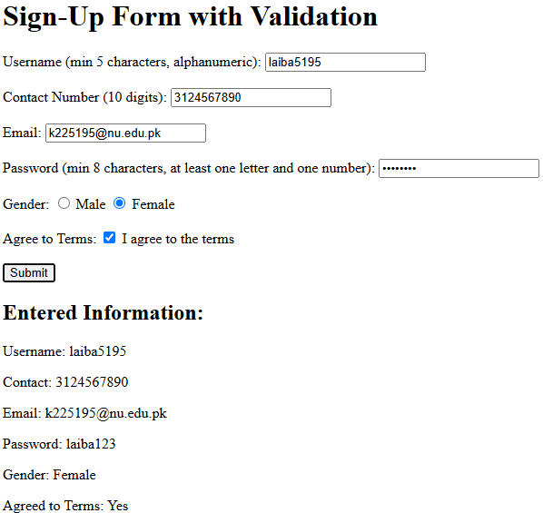

8)
<!DOCTYPE html>
<html lang="en">
<head>
<meta charset="UTF-8">
<meta name="viewport" content="width=device-width, initial-scale=1.0">
<title>Image Slider</title>
<style>
#slider {
width: 500px;
height: 300px;
overflow: hidden;
}
#slider img {
width: 100%;
height: auto;
}
</style>
</head>
<body>
<h1>Image Slider</h1>
<div id="slider">
<img src="https://images.unsplash.com/photo-1585076641399-5c06d1b3365f?q=80&w=1470&auto=format&fit=crop&ixlib=rb-4.0.3&ixid=M3wxMjA3fDB8MHxwaG90by1wYWdlfHx8fGVufDB8fHx8fA%3D%3D" alt="Image 1">
<img src="https://images.unsplash.com/photo-1607706189992-eae578626c86?w=500&auto=format&fit=crop&q=60&ixlib=rb-4.0.3&ixid=M3wxMjA3fDB8MHxzZWFyY2h8MTR8fGh0bWx8ZW58MHx8MHx8fDA%3D" alt="Image 2">
<img src="https://images.unsplash.com/photo-1505685296765-3a2736de412f?w=500&auto=format&fit=crop&q=60&ixlib=rb-4.0.3&ixid=M3wxMjA3fDB8MHxzZWFyY2h8MTl8fGh0bWx8ZW58MHx8MHx8fDA%3D" alt="Image 3">
</div>

<script>
let currentIndex = 0;
const images = document.querySelectorAll('#slider img');
const totalImages = images.length;

function moveSlider() {
images.forEach((img, index) => {
img.style.display = 'none';
});

images[currentIndex].style.display = 'block';

currentIndex = (currentIndex + 1) % totalImages;
}

setInterval(moveSlider, 3000);
moveSlider();
</script>
</body>
</html>

